Arup  
Software Documentation  
June 04, 2014

**Arup Issue Tracker**

1. Introduction

This document describes the functionalities and use of the Arup Issue Tracker (AIT) developed by CASE.

* 1. Summary

AIT is the result of the integration of the BCF standard, the web based Issue Tracking System JIRA and custom applications developed by CASE.

AIT is made up of three applications:

* a standalone Windows application (AIT for Windows)
* a Revit 2014 and 2015 Addin (AIT for Revit)
* a Navisworks 2014 and 2015 Addin (AIT for Navisworks)

AIT supports BCF 1.0 and has been tested and optimized for Tekla BIM Sight (TBS) 1.9.2.

* 1. Requirements
     1. General
* .NET 4.5 is required by the application, it can be downloaded from: <http://www.microsoft.com/net>
  + 1. JIRA specific
* A JIRA instance running on <http://jira.arup.com>
* JIRA REST API enabled
* The JIRA instance to have a custom field named GUID with ID: customfield_10900
* The following fields to be accessible for the designed JIRA projects:
  + Summary
  + Key
  + Created
  + Updated
  + Description
  + Assignee
  + Comment
  + Attachment
  + Reporter
  + Status
  + Priority
  + Resolution
  + Issuetype
* User accounts with permission to create issues in the designed JIRA projects
  + 1. Revit – IFC

To have successful exports from Revit 2014 to IFC it is necessary to:

* Update Revit to [Service Pack 2](http://knowledge.autodesk.com/support/revit-products/downloads/caas/downloads/content/revit-2014-update-release-2.html) – build number 20131024_2115 (requires [Service Pack 1](http://knowledge.autodesk.com/support/revit-products/downloads/caas/downloads/content/revit-2014-update-release-1.html))
* Install [IFC Exporter for Revit 2014](http://sourceforge.net/projects/ifcexporter/files/2014/)
* Install [IFC Exporter UI for Revit 2014](http://sourceforge.net/projects/ifcexporter/files/2014%20UI/)

To have successful exports from Revit 2015 to IFC it is necessary to:

* Install [IFC Exporter for Revit 2015](http://sourceforge.net/projects/ifcexporter/files/2015/)
  1. Installation

If provided through an installer please follow the steps.

If not provided through an installer, uncompress the archive and place the contained files as follows.

* + 1. Main Files

Move the following 1 folder:

* ARUP Issue Tracker\

To:

[DRIVE]:\Program Files (x86)\CASE\

If on a x86 system use:

[DRIVE]:\Program Files\CASE\

* + 1. Revit 2014

Move the following 1 folder:

* 2014\ARUP.IssueTracker.Revit

To:

[DRIVE]:\ProgramData\Autodesk\Revit\Addins\2014\CASE\

Move the following 1 file:

* 2014\ARUP.IssueTracker.Revit.addin

To:

[DRIVE]:\ProgramData\Autodesk\Revit\Addins\2014\

* + 1. Navisworks 2014

Move the following 1 folder:

* 2014\ARUP.IssueTracker.Navisworks\

To:

[DRIVE]:\Program Files\Autodesk\Navisworks Manage 2014\Plugins\

* + 1. Revit 2015

Move the following 1 folder:

* 2015\ARUP.IssueTracker.Revit

To:

[DRIVE]:\ProgramData\Autodesk\Revit\Addins\2015\CASE\

Move the following 1 file:

* 2015\ARUP.IssueTracker.Revit.addin

To:

[DRIVE]:\ProgramData\Autodesk\Revit\Addins\2015\

* + 1. Navisworks 2015

Move the following 1 folder:

* 2015\ARUP.IssueTracker.Navisworks\

To:

[DRIVE]:\Program Files\Autodesk\Navisworks Manage 2015\Plugins\

* + 1. BCF Icon

Official .bcfzip file icon is:

* BCFicon.ico

1. BIM Collaboration Format (BCF)

[BIM Collaboration Format (BCF)](http://www.buildingsmart-tech.org/specifications/bcf-releases/bcf-intro) is an open standard introduced by buildingSMART to enable workflow communication between different BIM (Building Information Modeling) software tools. BCF is a XML schema that encodes messages that inform a software package of issues found in the BIM model by another software tool. The implication is that only those issues and not the entire BIM need to be communicated between software.

* 1. BCF 1.0 Schema

A BIM Collaboration Format file will have extension .bcfzip and will be referred to as BCF report or BCF file. A report can contain one or more Issues, each Issue has a Title, a GIUD, a Snapshot, a Viewpoint and may or may not have comments. Issues inside a BCF report will be referred to as BCF issues.



1. BCF Icon

* + 1. Viewpoint

A viewpoint is a .bcfv file. It contains, formatted in XML, information about a 3D view in the model. It can be either perspective or orthogonal. It may or may not contain a list of GUIDs related to elements in the model (referred to as attached elements).

* + 1. Snapshot

PNG image file representing a preview of the relative Viewpoint generated from the source software tool.

* + 1. Comments

Each Issue may or may not have comments. Every comment has an Author, a comment Body a Status (UNKNOWN, INFO, ERROR, WARNING) and may have Verbal Status (string describing more in detail the status).

1. Interface

User interface is consistent across the three applications. The JIRA panel lets the user connect to the JIRA server and manage, import, export issues. The BCF panel is for managing BCF reports (.bcfzip files) and BCF issues.

* 1. JIRA panel
     1. Organization

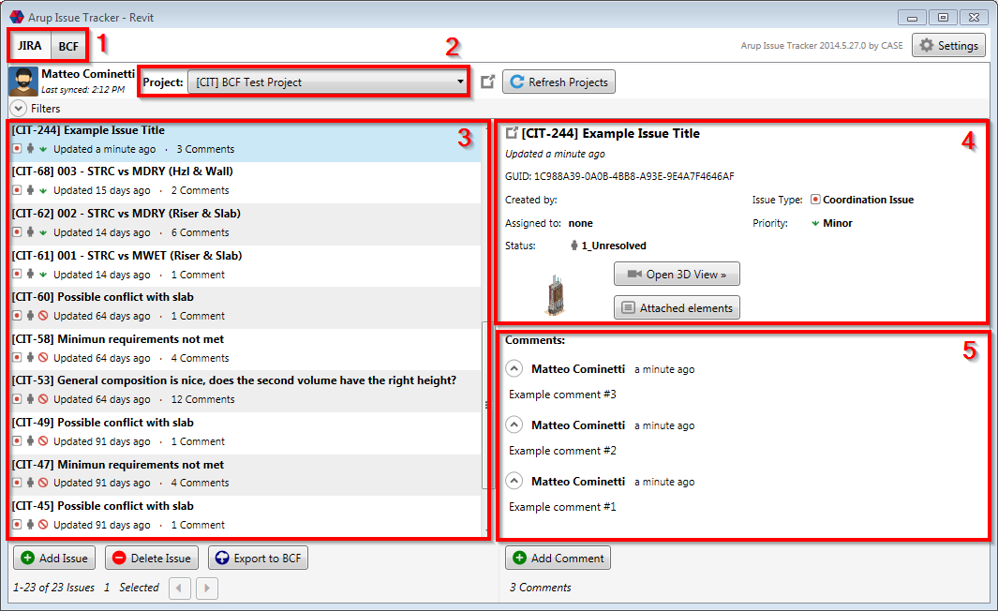

1. Tab control to switch between the JIRA and BCF panels
2. JIRA Project selection combo box
3. Issue List
4. Selected issue details (if multiple issues are selected, will display only the first)
5. Selected issue comments
   * 1. Actions

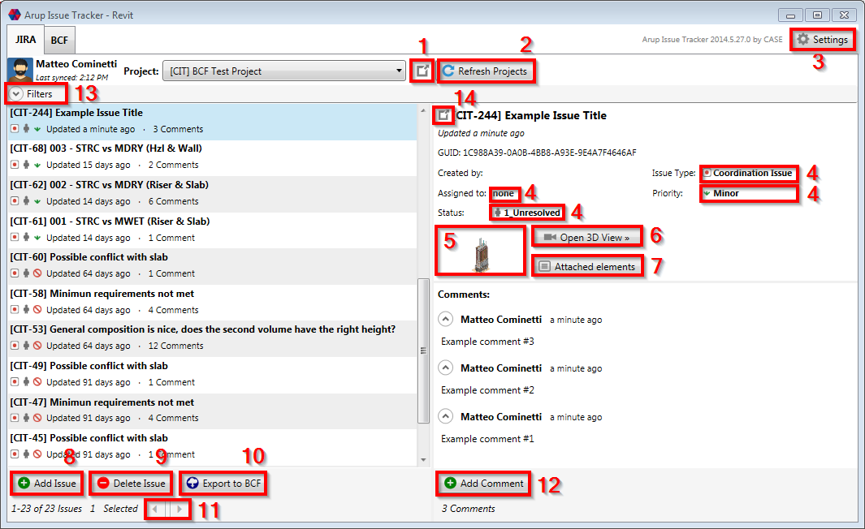

1. Opens the selected project in the browser
2. Reloads the list of projects and reselects the current one
3. Opens the Settings window
4. Changes relatively Assignee, Issue Type, Status or Priority for the selected issue or issues (change of status will only be applied to the first selected issue)
5. Opens the Snapshot in a new window
6. Creates a new view corresponding to the one defined in the Viewpoint. Available only in the Revit and Navisworks Addins
7. Opens a windows containing a list of attached elements
8. Creates a new Issue directly into JIRA (see specific page). Available only in the Revit and Naviswoks Addins
9. Deletes the selected issue or issues
10. Exports the selected issues to BCF. Only issues that have a viewpoint.bcfv and a snapshot.png attachments will be exported.
11. Pagination for when there are more than 50 issues in the list
12. Adds a comment to the selected issue or issues
13. Expands the Filter section (see specific page)
14. Opens the selected issue in the browser
    1. BCF panel
       1. Organization

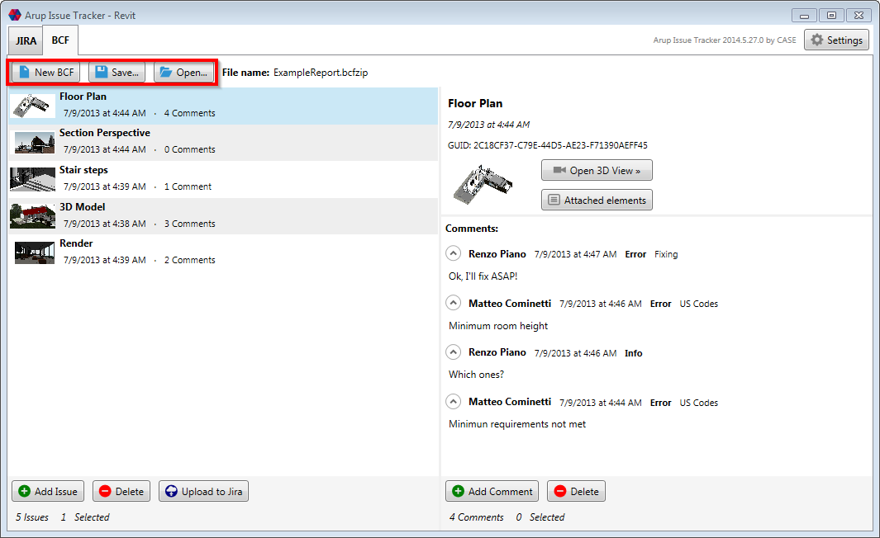

The BCF panel follows the same logic of the JIRA panel, but the project combo box is being replaced with a menu bar.

* + 1. Actions

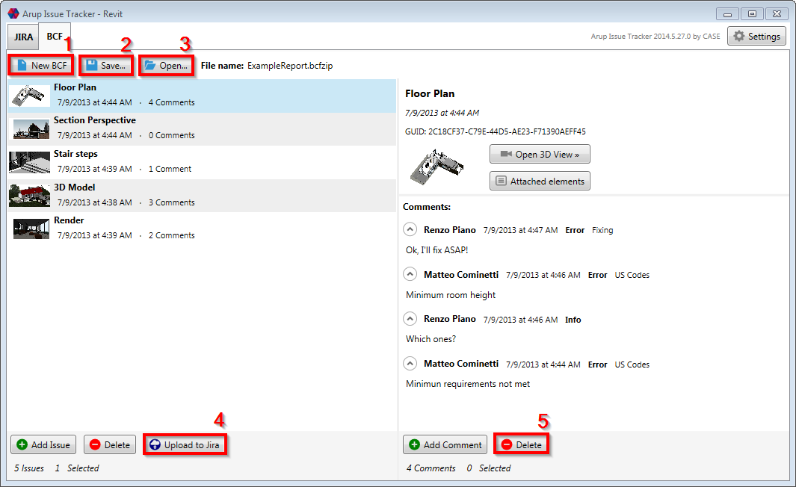

Same as in the JIRA panel with some exceptions:

1. Creates a new report clearing the current list of issues. Available only in the Revit and Navisworks Addins
2. Prompts to save the current report as BCF
3. Opens an existing report. N.B. reports can be also opened by dragging them onto the application’s main window (it will gray out)
4. Prompts to upload the selected issues to JIRA
5. Deletes the selected issue or issues
6. Settings

AIT has one main settings file editable through the “Settings” button within the applications and also project specific settings files available for Revit Projects.

* 1. Main Settings

Settings are stored in:

%LocalAppData%\CASE\ARUP Issue Tracker\ARUPIssueTracker.config

therefore are individual for each user on the machine. Settings are unique for the three applications and will not be overwritten by application updates.

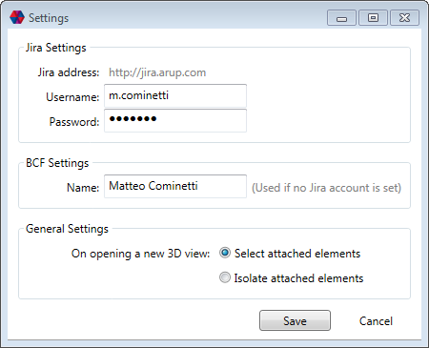

* + 1. JIRA Settings

By default at every application launch a connection to JIRA will be established only if Username and Password are filled in. To use the application without the online JIRA functionality simply clear up Username and Password fields and then save the settings.

* + 1. BCF Settings

The designed username will be used when creating new comments if no connection to JIRA is established.

* + 1. General Settings

Takes effect only in Revit and Navisworks when clicking the “Open 3D View” button. It will either select or isolate the attached elements to the Viewpoint if existing in the open model.

* 1. Revit Project Settings

Revit Projects Setting are optional and not created by default. In order to set up a Revit project settings file it is necessary to create a .bcfconfig file in the same folder as the .rvt file named as the Revit file (including extension). Therefore, for a SampleProject.rvt it will be necessary to create a SampleProject.rvt.bcfconfig file in the same directory and it will only affect BCF files used on that project.

The content of the .bcfconfig has to be structured as follows:

<?xml version="1.0" encoding="utf-8"?>

<configuration>

<appSettings>

<add key="useDefaultZoom" value="0" />

</appSettings>

</configuration>

* + 1. useDefaultZoom

Boolean: 0 false, 1 true. Defaul value = 0

Set it to 1 if working to/from Tekla so that Orthographic and Perspective views will be adjusted to its zoom factor. If not planning to exchange BCF files with Tekla set it to 1 so that views will not be scaled.

1. Usage

Usage of the three applications is the same, although AIT for Windows does not provide functionality to create new issues and open viewpoints. Furthermore- the way issues are created in the AIT for Revit and Navisworks is different.

* 1. General usage (AIT for Windows)

AIT for Windows can be accessed from:

[DRIVE]:\Program Files (x86)\CASE\ARUP Issue Tracker\ARUP.IssueTracker.Win.exe

If on a x86 system:

[DRIVE]:\Program Files\CASE\ARUP Issue Tracker\ARUP.IssueTracker.Win.exe

If provided during installation, via the Start Menu or by double clicking on a .bcfzip file.

All the following features are also available in AIT for Revit and Navisworks.

* + 1. Filters

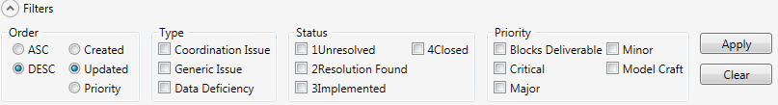

Issues can be filtered by Issue Type, Status and Priority. After selecting one or more filters and clicking “Apply” the filter bar will be highlighted.

N.B.

If a certain Issue Type, Status or Priority is being filtered out and a new issue with that Issue Type, Status or Priority is created it won’t be visible until that filter is cleared.

Order, not being a real filter, is always applied to the query retrieving the list of issues.

* + 1. Export JIRA issues to BCF

From the JIRA panel, by selecting one or more issues and clicking the “Export to BCF” it is possible to create a new BCF report containing the issues.

It is important to keep in mind the following:

* Only issues that have a viewpoint.bcfv and a snapshot.png attachments will be exported
* Only 1 viewpoint.bcfv and 1 snapshot.png per issue are allowed
* The issue description will not be exported
* The BCF issue and comments creation dates will reflect JIRA’s creation dates
* The BCF comments author dates will reflect JIRA’s author
* Issue Type and Priority will not be exported
* The JIRA issue Status will be used as Verbal Status for each BCF comment
* Each BCF comment will have a Status set to UNKNOWN
* A new GUID will be generated for each issue that does not have one set as JIRA’s GUID custom field
  + 1. Upload BCF issues to JIRA

From the BCF panel, by selecting one or more issues and clicking the “Upload to JIRA” it is possible to create new JIRA issues. The user will be prompted to select a project and an Issue Type for the new issues.

It is important to keep in mind the following:

* Author of the issues and comments will be the user currently logged in with a JIRA account and not the one set in the BCF file
* Creation date and date of issues and comments will be the current time while the operation is processing
* Status and Verbal Status will not be stored in the JIRA issue
* Default priority and status set in JIRA will be applied to the new issues
* If an issue with the same GUID is already existing in JIRA only new comments will be uploaded (by new comments it is intended comments whose body text does not already appear in the selected issue)
  1. Use in Revit

The AIT for Revit can be accessed from the CASE ribbon panel.

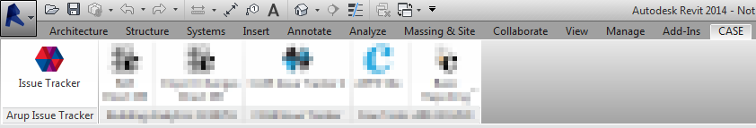

* + 1. Add an Issue

Adding a new issue to a JIRA project or to a BCF report follows the same procedure. The active view has to be either a 3D view (orthographic) or a camera view (perspective). After clicking the “Add Issue” button, the following window will appear:

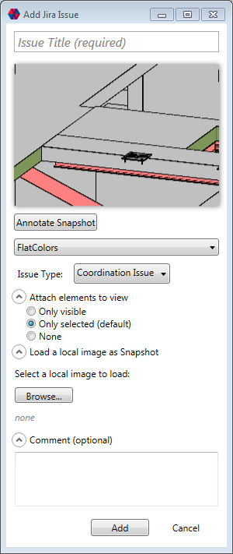

* An issue title is required
* The generated snapshot can be annotated clicking on “Annotate Snapshot” (N.B. you need to save and then close MS Paint for the changes to take effect)
* The “Attach elements to view” section lets the user decide which elements to attach to the issue. N.B. to attach selected elements, those needs to be selected before clicking the “Add Issue” button
* It is possible to change visual style of the snapshot by selecting a different one via the drop down menu
* It is also possible to load a local image via the “Browse” button
* Optionally a first comment can be added to the issue
  + 1. Open a 3D View

Opening a 3D view in Revit can only be done if the active view is not a perspective (camera) view; in that case switch to any other type of view (2D or 3D).

If the issue contains an orthographic view (as specified in the viewpoint file) it will be tried to open it into an existing orthographic view, orthewise a new one will be created.

If the issue contains a perspective view a new “BCFpersp” view will be created and used for the following perspective views.

Attached elements will be either selected or isolated accordingly to the settings.

* 1. Use in Navisworks
     1. Add an Issue

Issues in Navisworks are added from existing Saved Viewpoints. The process of adding a new issue is different than in Revit since it’s meant to happen for more issues at the same time (i.e. batch creation after a clash test).

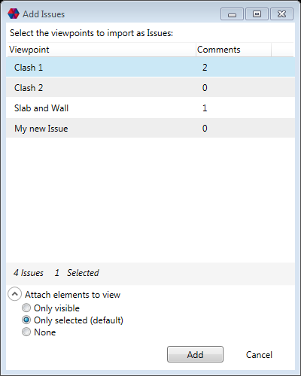 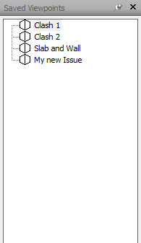

After Clicking “Add Issue” it is possible to select one or more Viewpoints to add as issues, the “Attach elements to view” section lets the user decide which elements to attach to the issue. N.B. to attach selected elements, those needs to be selected before clicking the “Add Issue” button. Only Selected Viewpoints will be used and their comments will be used as BCF or JIRA comments.

* + 1. Open a 3D View

Opening a 3D view works the same way as in Revit, but the active view will always be used and no view will be added to the “Save Viewpoints” panel.

* 1. Model export from Revit
     1. Revit to Tekla

Please refer to the requirements chapter before proceeding. Go to: *Revit>Export>IFC>Modify Setup…*

Mind to check “Include IFCSITE Elevation in the site local placement origin”.

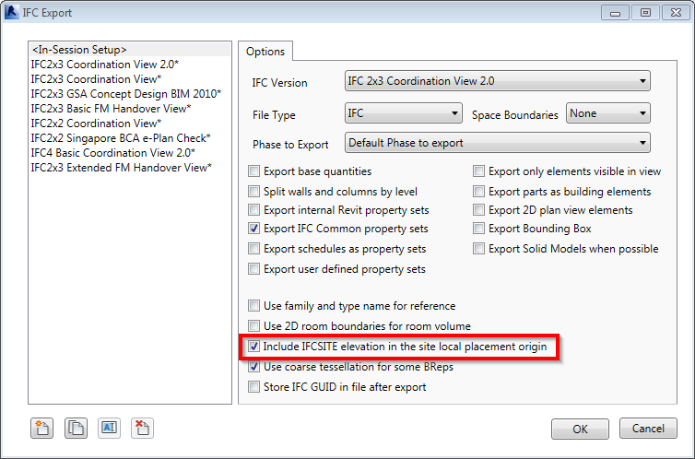

* + 1. Revit to Navisworks

For optimal results, it is suggested to use the NWC export utility from within Revit and export as NWC or to use an IFC file generated as mentioned above.

* 1. Known Limitations
* The way BCF files are interpreted/created by software vendors is different, in particular concerning the FOV of perspective views and the scale of orthogonal views. Viewpoints might result in having different “zoom/scale” and location. AIT is optimized to work with Tekla BIM Sight and Navisworks, but full compatibility cannot be guaranteed with BCF files coming from other software
* No more than one snapshot/viewpoint are allowed per issue, as for BCF 1.0 schema
* No 2D views are allowed: issues cannot contain plan views, sections, details and elevations, as for BCF 1.0 schema
* No native tools as section boxes or crop regions are supported by BCF
* When uploading BCF files to JIRA the issue and comment dates will reflect the creation date on JIRA and not the one of the BCF file itself
* BCF assigns statuses to comments while JIRA to issues
* Attaching all the visible elements to a new issue from very big models in Navisworks and Revit could crash the application since it needs to loop through all the model’s elements
* A current limitation in the Revit API does not allow to access elements that are part of a linked model. Consequence is that attached elements cannot include linked models